Welcome!
Date
Name
Spouse
Address
City
State Zip _________
Email

Please Contact By
❑ Card  Phone  Visit

Telephone Best Time to Call
Home ______________
Work ______________

Guest: First Time Second Time
Are you a church member: yes no
Church
City, State

Circle Appropriate Age/Grade Group(s)
Preschool: Ages: B-1 2-3 4-5
Children: Grades: K 1 2 3 4 5 6
Youth: Grades: 7 8 9 10 11 12
Adults: Ages:18-29 30s 40s 50s 60s+

How did you learn about our church?
Newspaper Friend Yellow Pages Mail
Other

I am a guest of:

New in the Community? Yes No
Names & ages of children at home

Weekly Service & Activity Schedule
March 30, 2014
9:45 a.m. Sunday School
11 a.m. Morning Worship

6 p.m. Evening Service

Week of March 31 – April 5
Wednesday, 6:30 p.m. Youth Activities
Wednesday, 6:45 p.m. Adult Prayer & Bible Study
Wednesday, 7:30 p.m. Praise Team Rehearsal
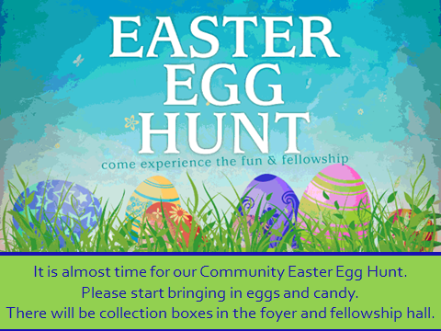
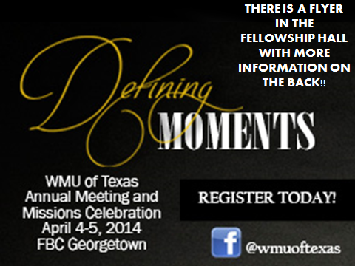

Upcoming Events
April
6 Lord’s Supper
6 Kids in Action
10 Adult Fellowship – 10 am
12 Community Easter Egg Hunt
13 Business Meeting
18 Good Friday
20 Easter Sunday
24 Adult Fellowship – 10 am
27 Musicians and Church Staff Appreciation Day

Birthday & Anniversary Recognitions will occur on the final Sunday of each month.

Knobbs Springs Baptist Church

As for you,
you were dead in your transgressions and sins, in
which you used to live when you followed the ways of
this world and of the ruler of the kingdom of the air,
the spirit who is now at work in those who are
disobedient. All of us also lived among them
at one time, gratifying the cravings of our flesh and
following its desires and thoughts. Like the rest,
we were by nature deserving of wrath. But because
of his great love for us, God, who is rich in mercy,
made us alive with Christ even when we were dead
in transgressions—it is by grace you have been saved.
And God raised us up with Christ and seated us
with him in the heavenly realms in Christ Jesus,
in order that in the coming ages he might show the
incomparable riches of his grace, expressed in his
kindness to us in Christ Jesus. For it is by grace
you have been saved, through faith—and this is not
from yourselves, it is the gift of God— not by works,
so that no one can boast. For we are God’s handiwork,
created in Christ Jesus to do good works,
which God prepared in advance for us to do.
Ephesians 2:1-10

March 23, 2014

Church Information:

KnobbsSpringsBC.com KnobbsSpringsBaptist@gmail.com
1662 CR 305, McDade, Texas 78650 512-273-2743
Brother Dwight Reagan 512-247-6448
Kimberly Tabor, Office Manager 512-698-2804

